**C.1**

x=[-1:0.01:1];

x0=[-1 -0.9511 -0.8090 -0.5878 -0.3090 0 0.3090 0.5878 0.8090 0.9511 1];

n=size(x0,2);

for i=1:n

p=1;

for j=1:n

if j==i

continue;

endif;

p=p.*(x-x0(j))/(x0(i)-x0(j));

figure(i)

plot(x,p);

xlabel('x')

ylabel('y')

endfor;

endfor;

圖從左至右依序為x0,x1,…,x10

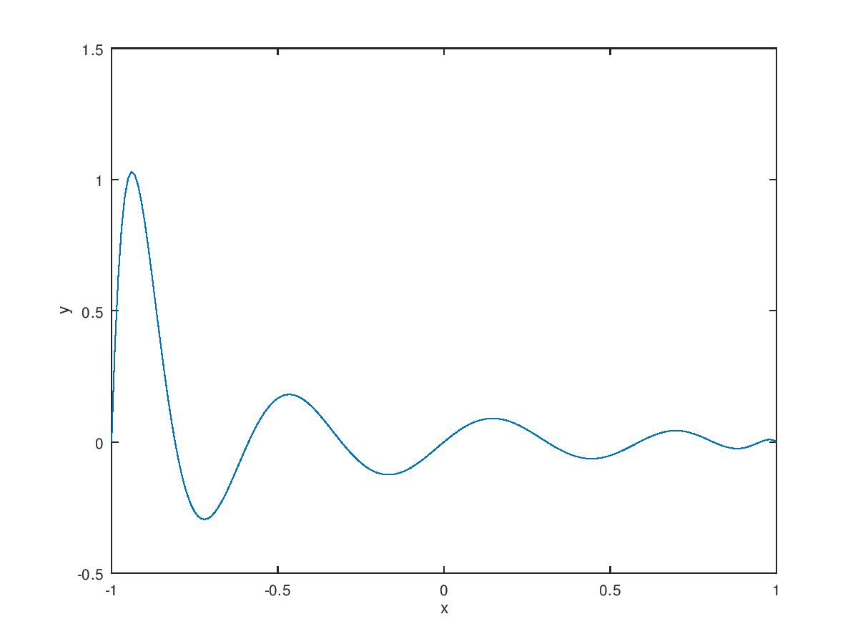

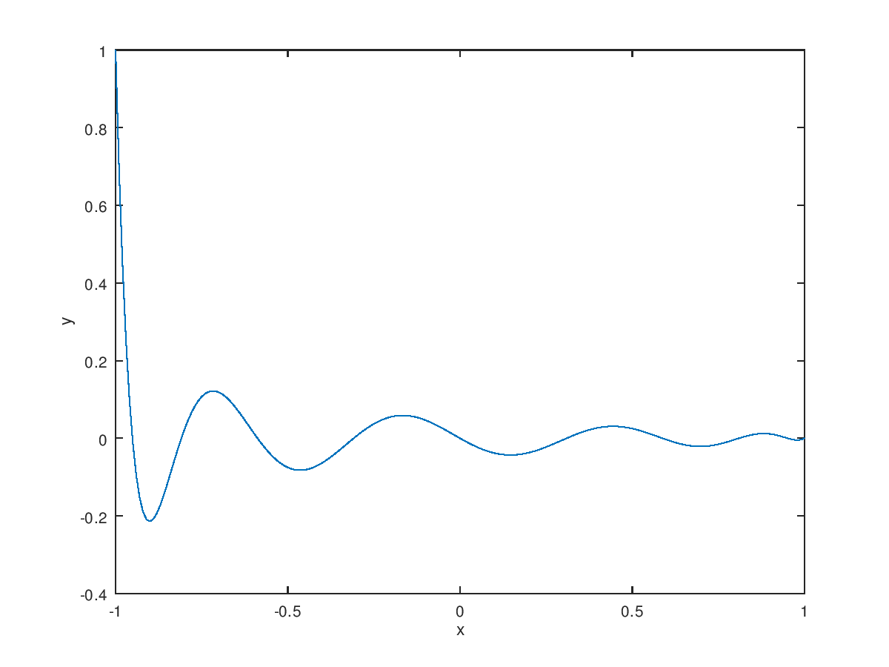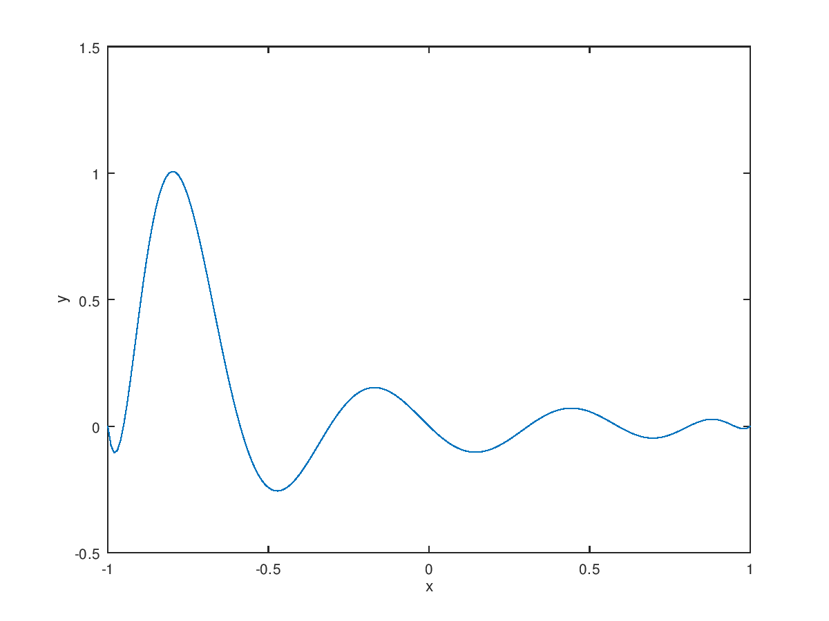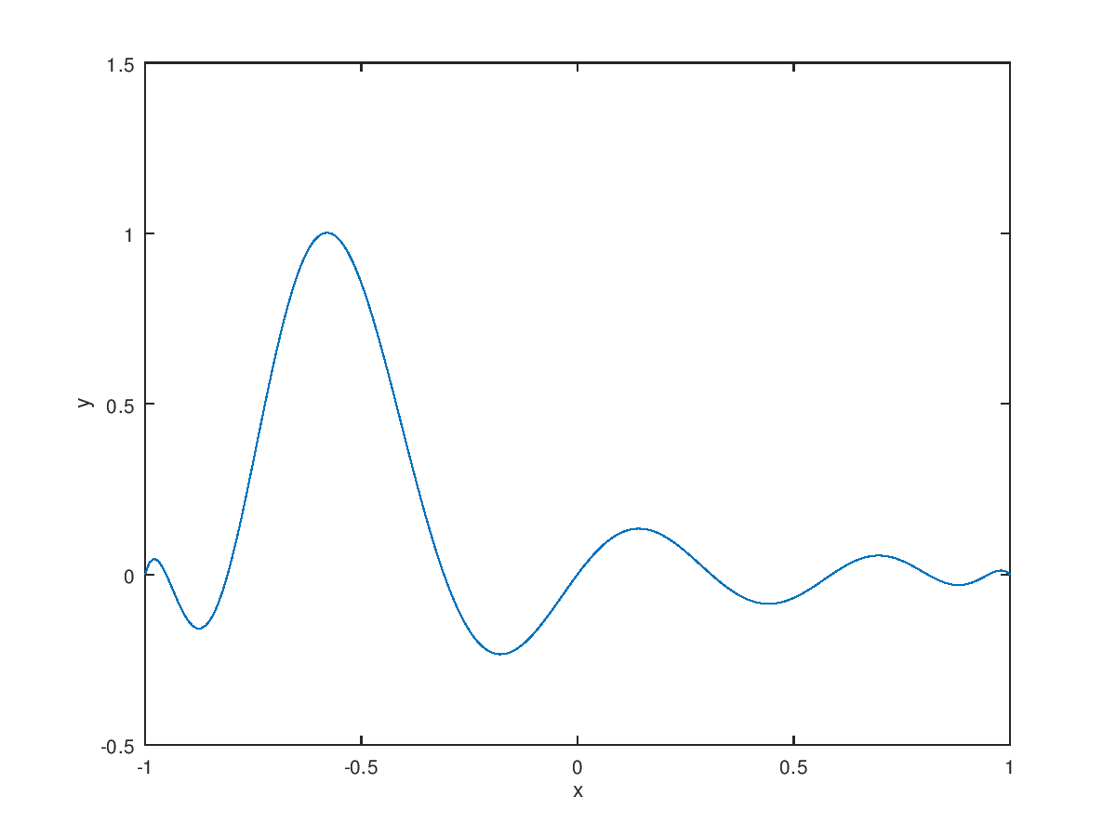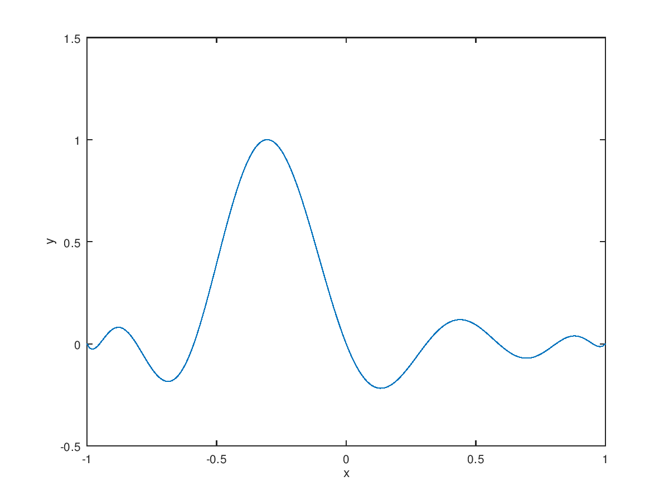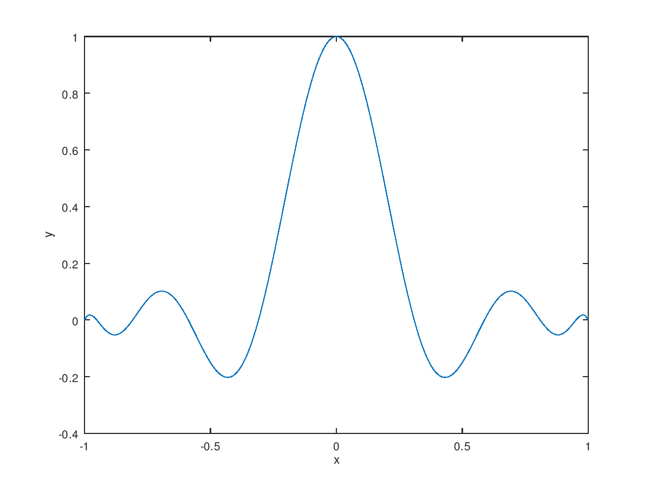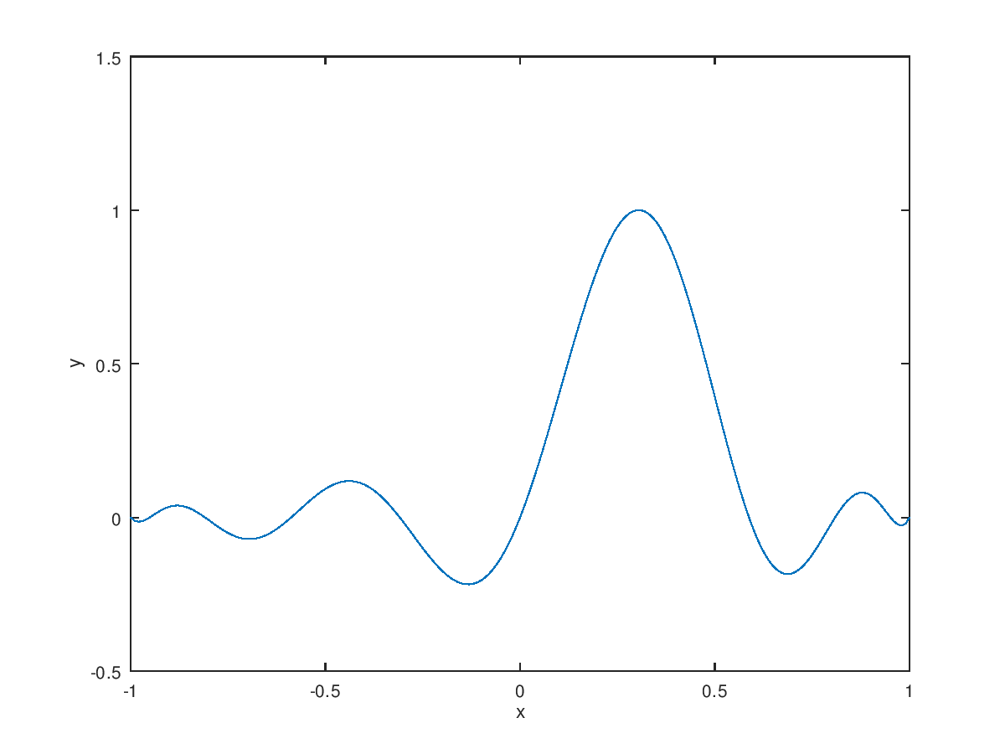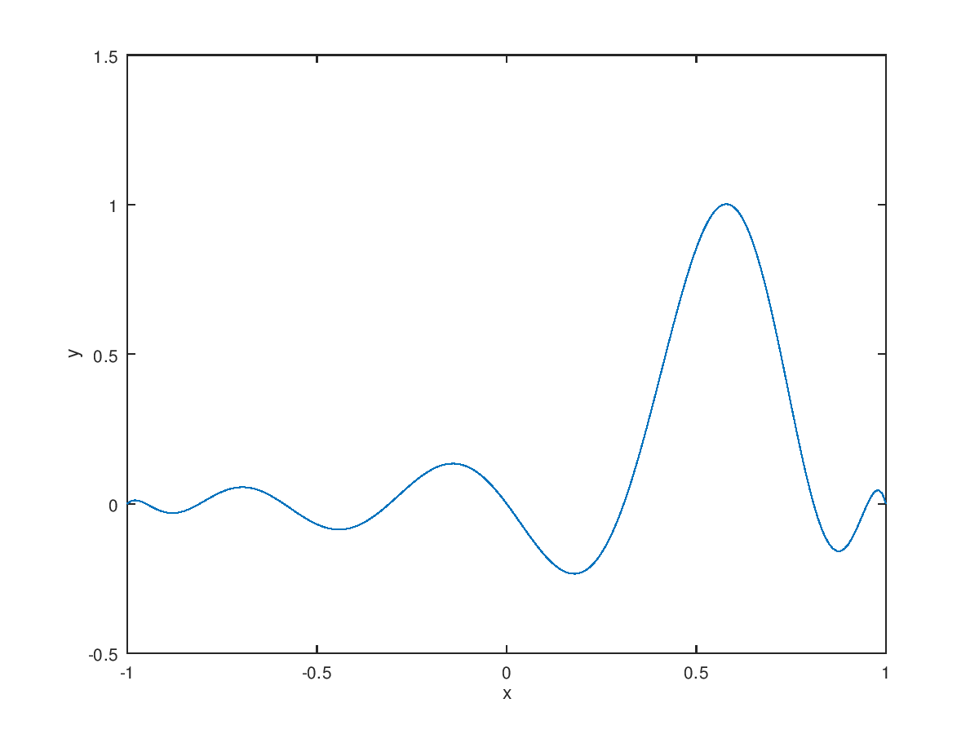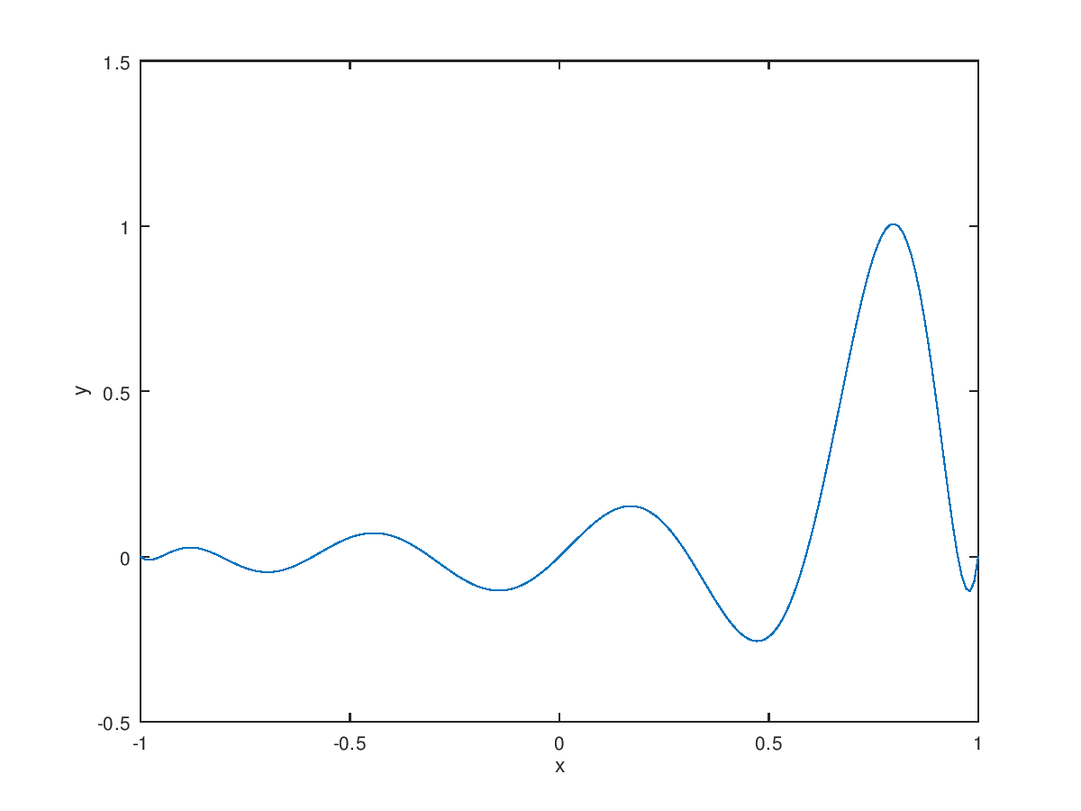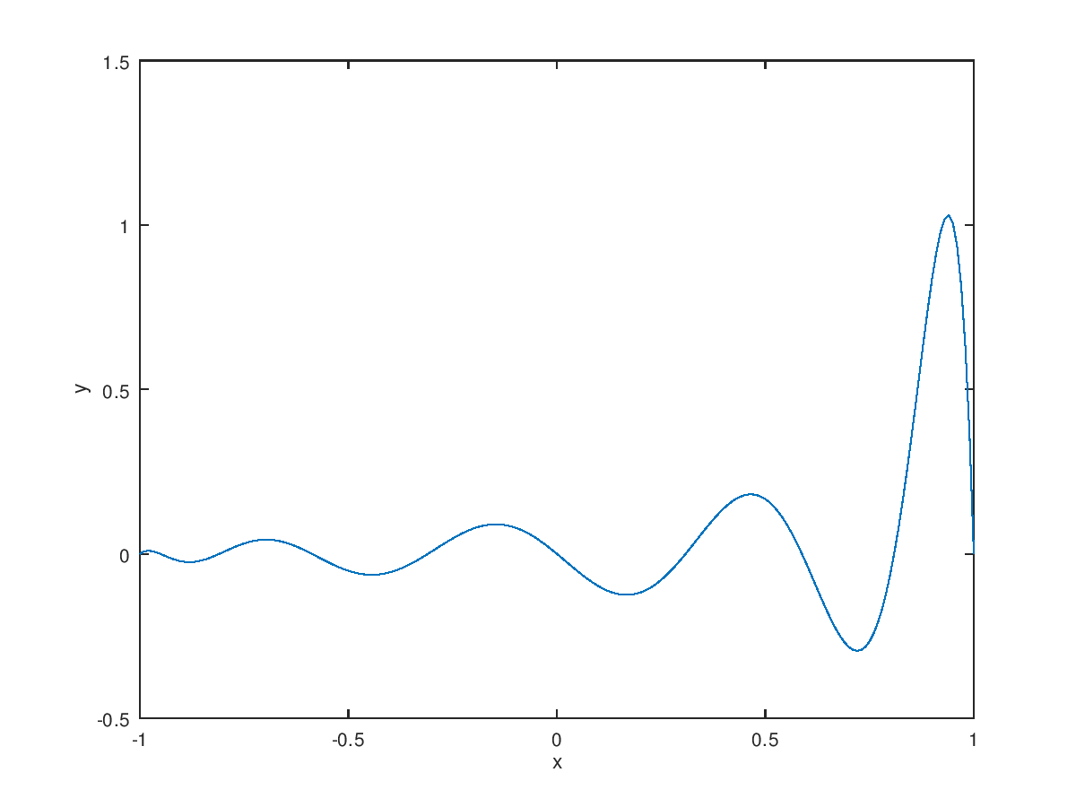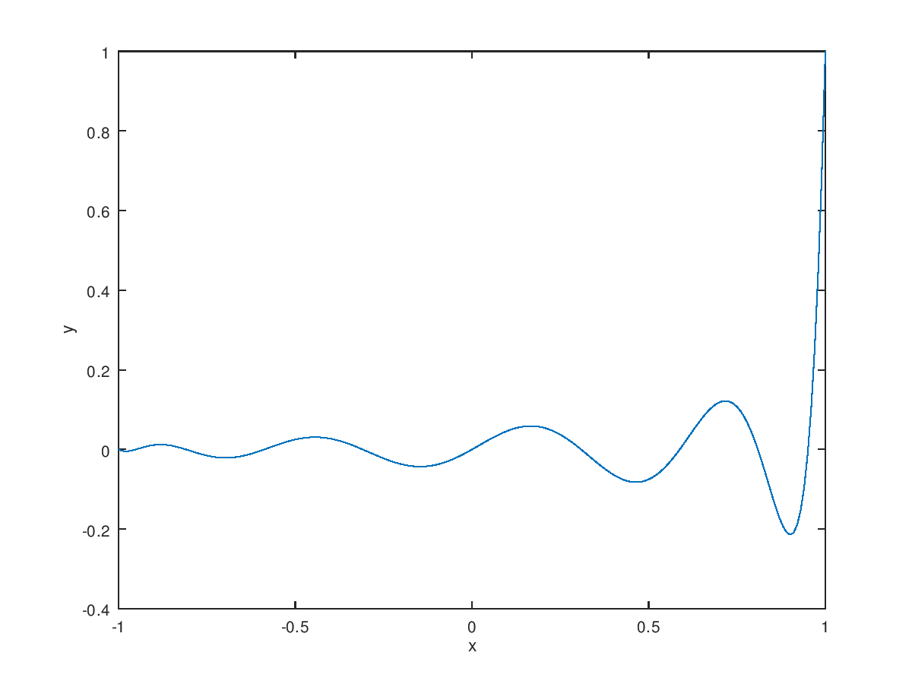

**C.2**

x=[-1 -0.9511 -0.8090 -0.5878 -0.3090 0 0.3090 0.5878 0.8090 0.9511 1];

y=[0.0385 0.0424 0.0576 0.1038 0.2952 1 0.2952 0.1038 0.0576 0.0424 0.0385];

function y=LagrangePol(x,pointx,pointy)

n=size(pointx,2);

L=ones(n,size(x,2));

for i=1:n

for j=1:n

if(i~=j)

L(i,:)=L(i,:).*(x-pointx(j))/(pointx(i)-pointx(j));

end

end

end

y=0;

for i=1:n

y=y+pointy(i)*L(i,:);

end

end

plot(x,y,"o","markersize",5)

hold on;

t=[-1:0.1:1];

plot(t,LagrangePol(t,x,y))

xlabel('x')

ylabel('y')

print -dpng output.png

